**Building Blog Application on Cloud**

**19CSE453 CLOUD COMPUTING Project**



|  |  |
| --- | --- |
| **Roll Number** | **Name** |
| CB.EN.U4CSE20655 | SHANJAI KUMAR V M |

**Table of contents**

1. **Motivation…………………………………………………………………………………………**
2. **Technology/Tools/stacks……………………………………………………………………..**
3. **Services……………………………………………………………………………………………….**
4. **Cloud Service usage……………………………………………………………………………..**
5. **Video project Demonstration………………………………………………………………..**
6. **UI Design………………………………………………………………………………………………**

**Motivation**

In the current Running world Role of Digitalization has become more familiar to Public .

To share our thoughts , memories , Knowledge **Blogging** Applications plays the crucial role

In connecting Audiences to Different Topics. To Manage Large volumes of Data(Contents, heading ,thumbnails) **Cloud** performs the crucial Role in providing Good Experience to Customers.

* 1. **Iaas** ( memory , storage , hardware)
  2. **Security** (Restricted access)

**Technology/stacks/Tools**

1. **Frontend**: HTML , CSS , JS
2. **Backend**: NodeJS , Express
3. **Database:** Mysql2

**Cloud**

Google Cloud Platform (GCP)

**Services**

1. Navigation Menu > Cloud Storage > **Buckets**
   1. **IAM & admin >** permissions

Principles: allUsers

Role: Storage Object Viewer

1. **Cloud Functions** > Cloud Storage trigger

* Api & Services > Enabled API’s Services > **cloud Functions API**
* Api & Services > Enabled API’s Services > **Eventarc API**
* Api & Services > Enabled API’s Services > **Artifact Registery API**

1. **Vm Instance**

* Network Policy > **Firewall policies**
* Api & Services > Enabled API’s Services > Compute Engine API

1. **Sql > mysql**
2. **CDN** (content Delivery Network)

* **Logging > logs viewer**

**Cloud Service Usage:**

1. ***Bucket*** [cloud_proj_blog ]

Instead of adding Images in Sql Database I’ve added images in Bucket to Ensure the Controlled access of viewing the contents means Only if name is present the Bucket the article gets added to article

Using Bucket in Gcp Reduced The overall File Size and it is available all time

1.1)**Screenshots:**

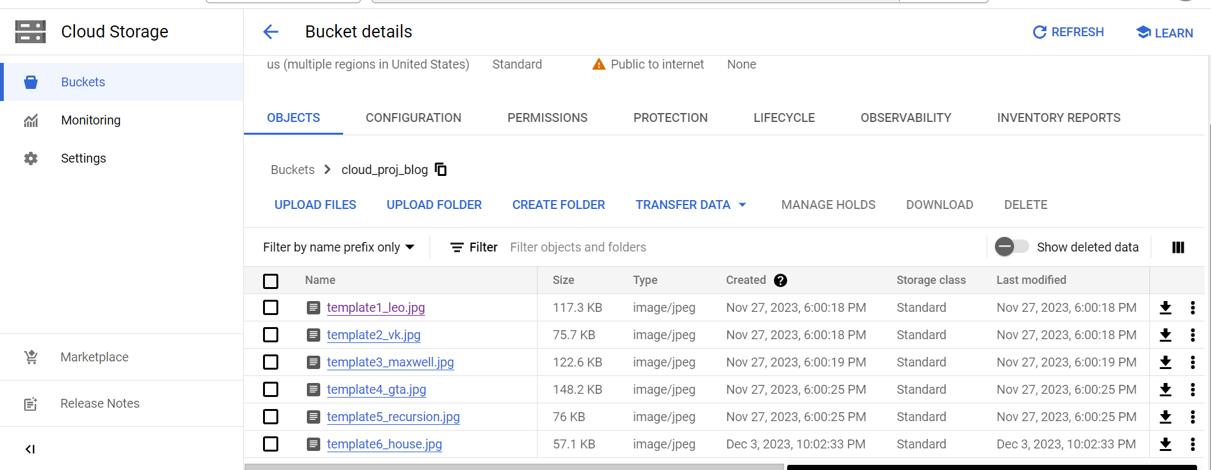

1.2) **Commands**

gsutil mb gs://bucket_name

permissions > grant_permissions > principles(allUsers) > Role(Storage Object viewer)

**2)VM Instance**

Using Vm instance project_blog I was able To install nodejs package and able To execute the program

Gcp Configured Instance with providing Infrastructure to Run:

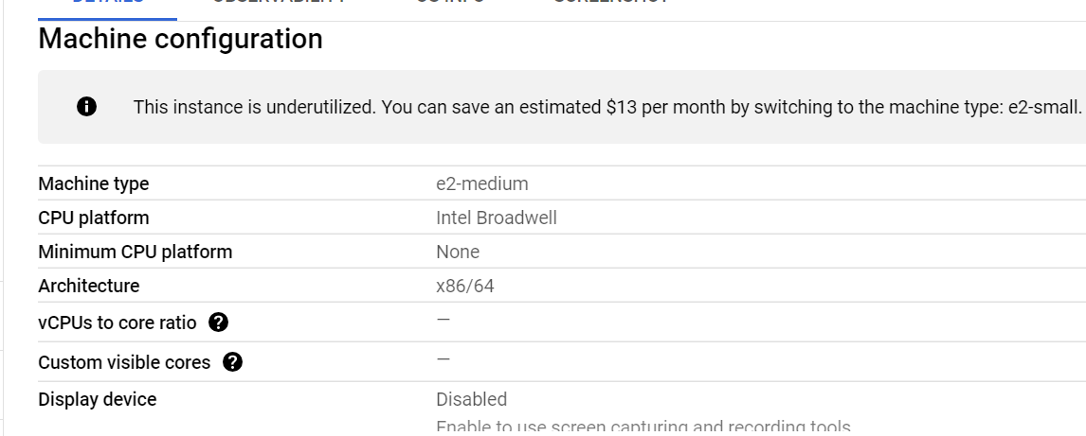

**2.1) Screenshots**

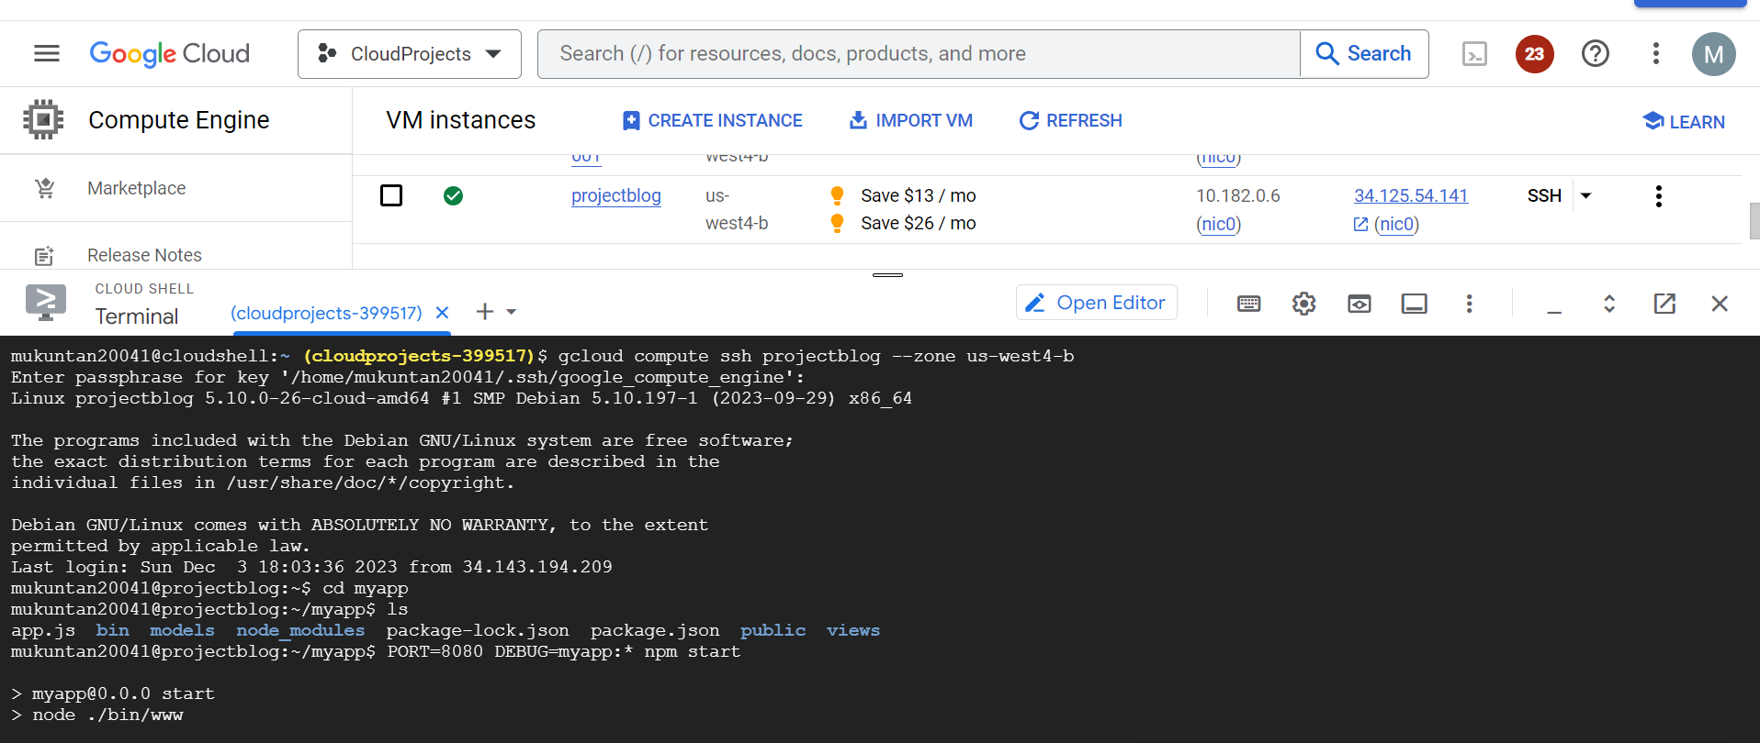

**2.2) Commands**

1. npx express-generator — view**=**ejs {dir_name}
2. cd {dir_name}
3. npm install
4. wget https://dev.mysql.com/get/mysql-apt-config_0.8.22-1_all.deb
5. sudo dpkg -i mysql-apt-config*
6. click open_editor to change to your code
7. PORT**=**8080 DEBUG**=**{dir_name}:**\*** npm start
8. Click on Web Preview > preview on port 8080

**3) SQL**

Using Gcp sql Service I was able To connect **project_blog** Virtual Instance to sql **blog_posts.** This helped in Managing Backend Database and analysing the Response

**3.1) Screenshots**

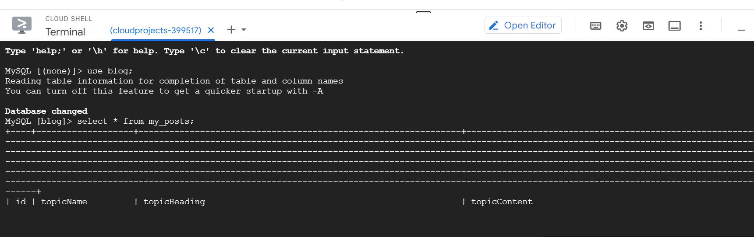

**3.2) Commands:**

a) sql la virtual ip save

b) mysql -h sql_ip -u root -p

**4) CLOUD FUNCTION(BUCKET TRIGGER)**

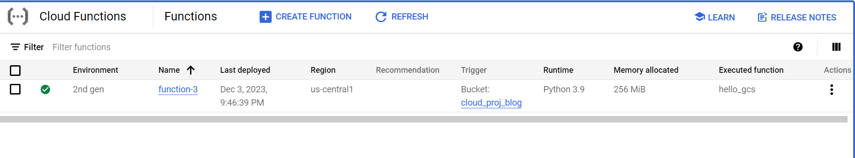

Once The image is created on Bucket the trigger Function Triggers and Display the msg

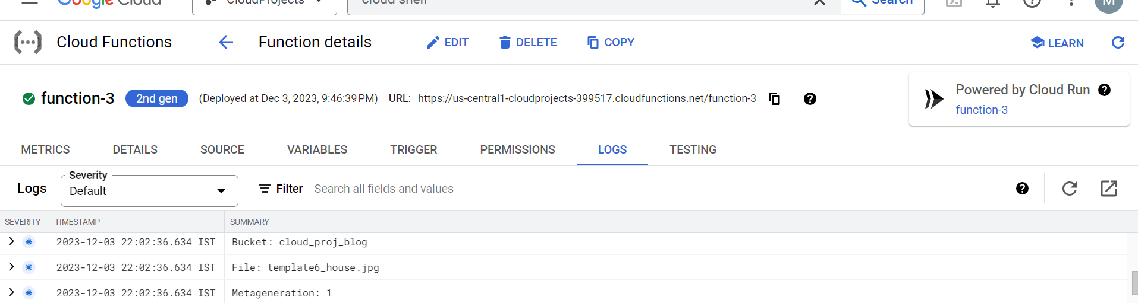

**5) CDN(Content Delivery Network)**

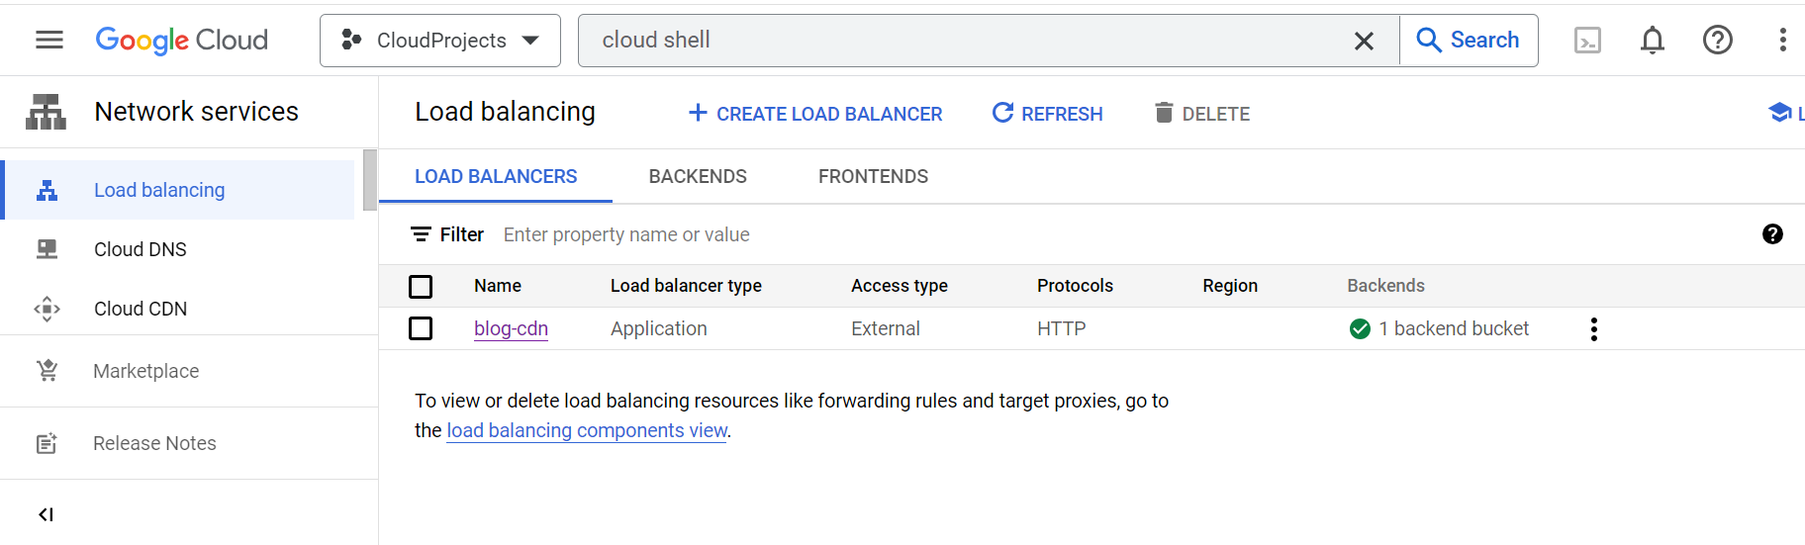

Loads static content Faster

**Video Project Demonstration:**

**Link:** [PROJECT_DEMONSTRATION.mkv](https://1drv.ms/u/s!AqQ8CmYDoMI92wuMx5K2jJqitLRC?e=vW0v6Q)

**Source Code:** <https://github.com/sAnju3888/shanjai4.0/tree/main>

**UI DESIGN**

**Feautres**

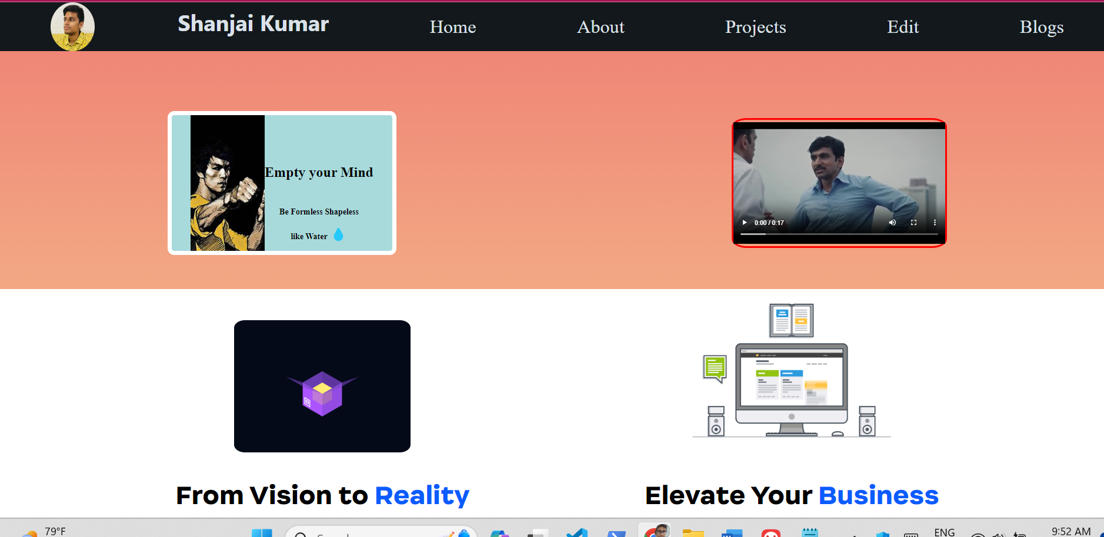

Portfolio web Home page with Nav Bar Quotes images

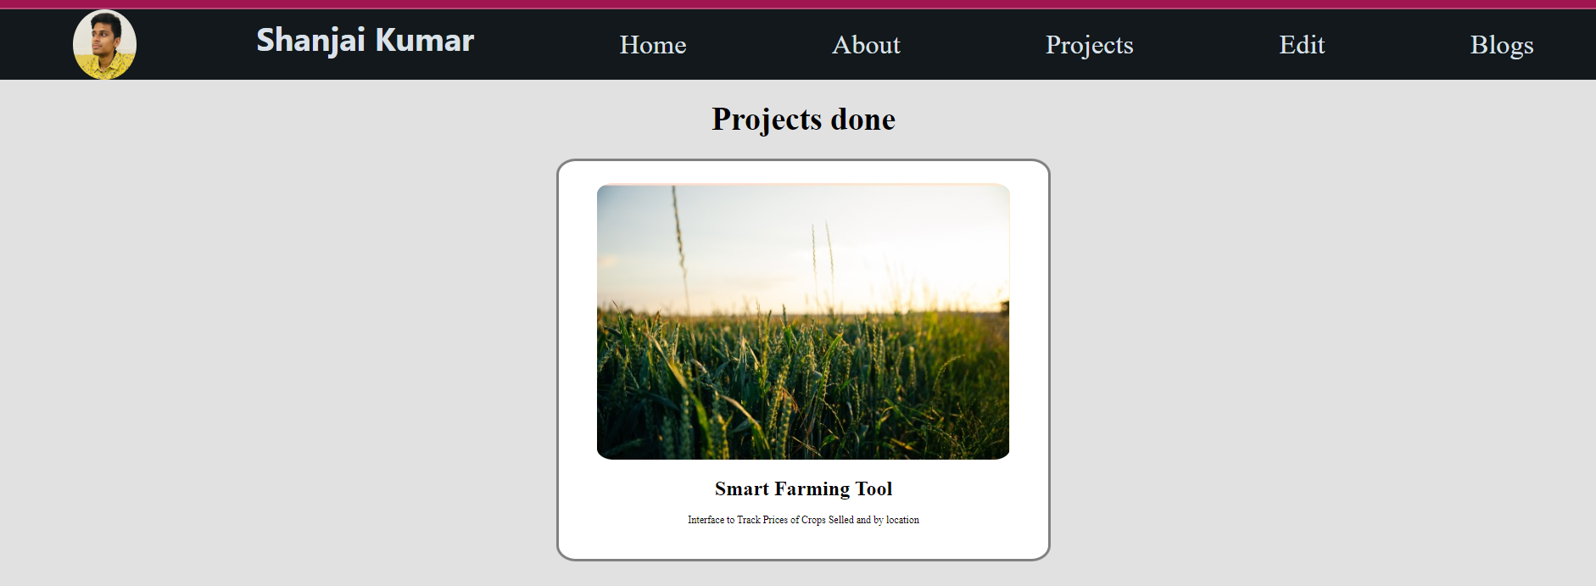

Project Pages which Lists Past Project done by me and a short Description on it

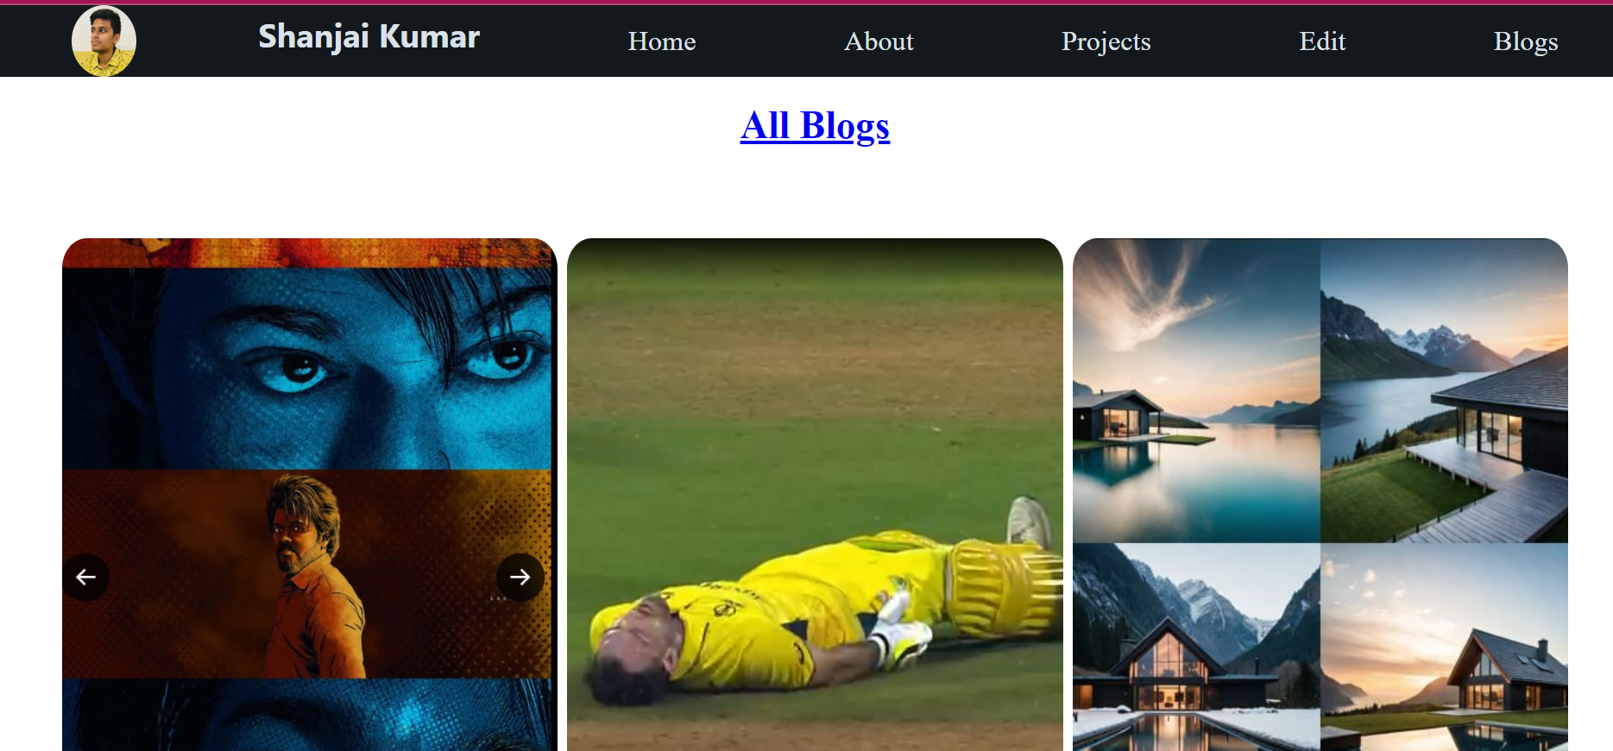

This Page Displays the Blog written By me

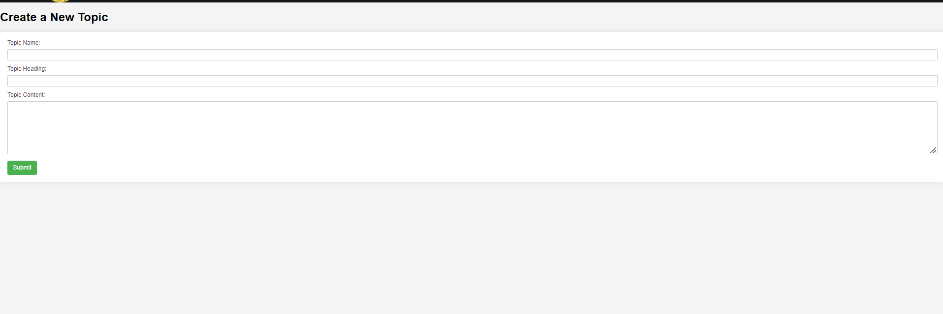  
In this Form We Can Write the contents for the Article